Tyler McKean README for Project 1 Basic GPIO Programming

BASIC STRUCTURE

This program utilizes the joystick of the STM32L476 Microcontroller as inputs to do the following task:

* Toggles both the onboard RED and GREEN LEDs when the center button is pressed.
* Turns on both the onboard RED and GREEN LEDs when the up button is pushed.
* Turns off both the onboard RED and GREEN LEDs when the down button is pushed.

To achieve these tasks the Clock was enabled to GPIO Ports A, B and E.

* GPIO Port A is tied to the joystick of the discovery board with pins PA0 being the center button, PA3 being the up button, and PA5 being the down button.

Pin PB2, the RED LED, and Pin PE8, the GREEN LED needed to set as outputs in the MODER by having the values 0x01 at pins 4 and 5 for PB2 and pins 16 and 17 for PE8.

Pins PB2 and PE8 then needed to be set as output type push-pull in the OTYPER by having the value 0x00 at both pin 2 for PB2 and pin 8 for PE8.

The joystick pins then needed to be configured as inputs in the MODER by having the value 0x00 at pins 0 and 1 for PA0 (center button), pins 6 and 7 for PA3 (up button), and pins 10 and 11 for PA5 (down button).

The center button PA0 is already tied to ground by default, so both pins PA3 and PA5 needed to be set as output push-pull in the OTYPER, and then initialized as pull-down in the PUPDR to ground them. To set PA3 and PA5 as output push-pull the value 0x00 needed to be set to pins 3 and 5 in the OTYPER and then have the value of 0x10 at pins 6 and 7 for PA3 and pins 10 and 11 for PA5 in the PUPDR. The center button, PA0, also needed the value of 0x00 at pins 0 and 1 to be set as no push-pull in the PUPDR.

I chose to use masks that would read the individual bits of the IDR, these were classified as uint32_t and were named mask0, mask1, and mask2. mask0 was assigned as 1UL, which would read pin 0 of the IDR to check when the center buttons was pushed. mask1 was assigned as 1UL<<3, which would read pin 3 of the IDR to check when the up button was pushed. Finally, mask2 was assigned as 1UL<<5, which would read pin 5 of the IDR to check when the down button was pushed.

To achieve the tasks required for this project, 3 loops needed to be created in order to check at the states of the pins in the IDR.

* To toggle both RED and GREEN LEDs, an if loop was created to check when pin 0 in the IDR was equal to the value 1UL, which was assigned and compared to mask0. When this if statement was true the XOR bitwise operator ^= was used on GPIO_ODR_ODR_2 for RED LED and GPIO_ODR_ODR_8 for GREEN LED, which would toggle their logical states. A while loop was then used to sustain the program to keep the LEDs either on or off.
* To turn on both the RED and GREEN LEDs, another if loop was created to check when pin 3 in the IDR and mask1 were not equal (!=) to 0x00. When this if statement was true the OR bitwise operator |= was used on GPIO_ODR_ODR_2 for RED LED and GPIO_ODR_ODR_8 for GREEN LED, which would turn on and keep both LEDs on after pressing the up button once. . A while loop was then used to sustain the program to keep the LEDs on.
* To turn off both the RED and GREEN LEDs, a final if loop was created to check when pin 5 in the IDR and mask2 were not equal to 0x00 using a bitwise operator, !=. When this if statement was true it would clear the values set to GPIO_ODR_ODR_2 for RED LED and GPIO_ODR_ODR_8 for GREEN LED and be able to turn them off after being turned on by pressing the center button or up button. A while loop was then used to sustain the program to keep the LEDs off.

HOW TO TEST

* To test this project, simply plug the USB cable into the STM32L476 into the computer and run the project file in Keil uVision 5.
* After a successful build, click the debug option and press the reset button on the discovery board
* From here, both LEDs will be off. If you press the center button of the joystick on and off, the RED and GREEN LEDs will toggle.
* When both LEDs are off and you press the up button the LEDS will turn on and remain on.
* You can then press the center button again to toggle the LEDs on and off even after pressing the up button. Pressing the up button with the LEDs already on will not toggle or turn them off.
* If both LEDs are on after pressing the center button or up button, pressing the down button on the joystick will turn the LEDs off. Notice that if you press the down button when the LEDs are off, nothing will happen.
* Doing these action will prove that the project works correctly.

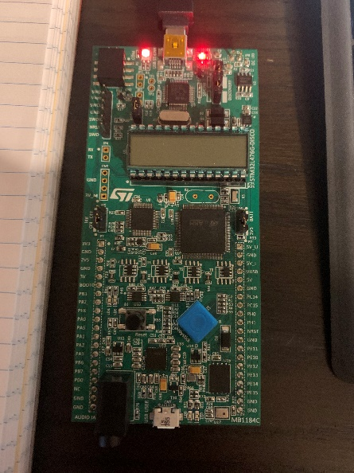TEST PROCEDURE

After building the project file and clicking the debug button in Keil uVision the discovery board’s LEDs will turned off.

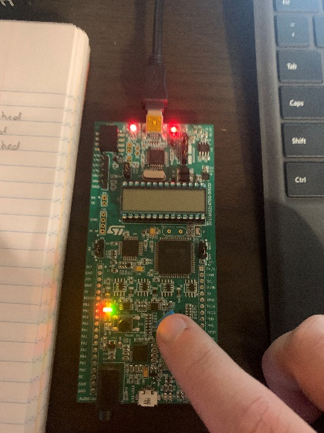Clicking the center button of the joystick will turn on the RED and GREEN LEDs, clicking again will turn them off.

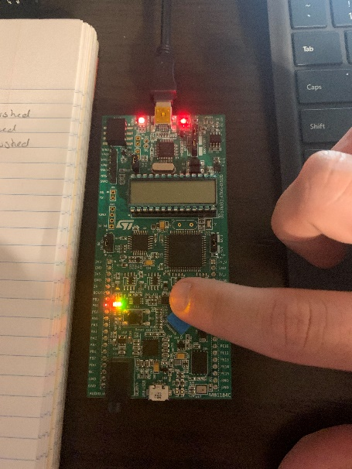With the LEDs off, clicking the up button of the joystick will turn on the LEDs. Clicking the up button again will not turn them off, LEDs will remain on.

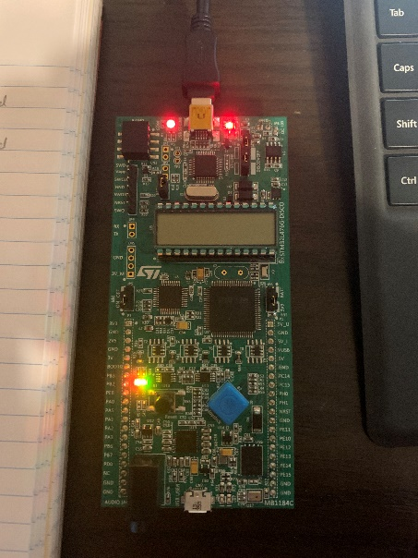

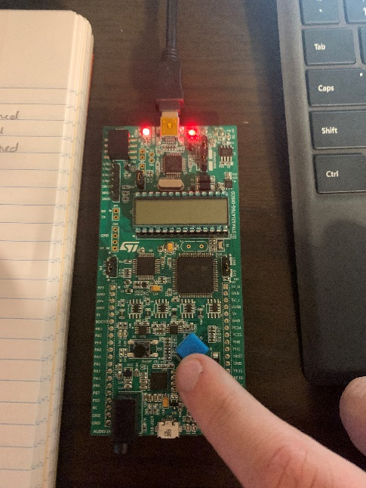Pressing the down button of the joystick with the LEDs turn on will turn them off. Pressing the down button again will not turn them back on.

TEST COMPLETE